Do this only inside your isolated cyber range. Keep these systems disconnected from production or public networks.
1. Windows 10 Pro (192.168.30.30)
A. SMB Exposure
- ☐ Enable File and Printer Sharing
- ☐ Create a shared folder with weak permissions
- ☐ Allow SMB over the lab network
Attack
- SMB Enumeration
- Share enumeration

B. Weak Local User
- ☐ Create:
  - Username: admin
  - Password: Password123
Attack
- Password spraying (lab only)
- Login attempts

C. RDP Enabled
- ☐ Enable Remote Desktop
- ☐ Allow RDP through Windows Firewall
Attack
- RDP discovery
- RDP enumeration

D. Sysmon
- ☐ Install Sysmon
- ☐ Enable PowerShell logging
Purpose
Generate telemetry for Wazuh.

E. Defender
For specific demonstrations only:
- ☐ Disable Defender Real-Time Protection temporarily (optional)

F. PowerShell
- ☐ Enable PowerShell
Attack
- Encoded commands
- Download cradle
- Process creation

2. Ubuntu + DVWA (192.168.70.10)
A. DVWA
Set Security Level:
Low

B. Enable Vulnerable Modules
- ☐ SQL Injection
- ☐ Command Injection
- ☐ File Upload
- ☐ File Inclusion
- ☐ Brute Force
- ☐ XSS

C. Apache
Enable:
- ☐ Access logs
- ☐ Error logs

D. SSH
Enable SSH.
Create:
user: admin
password: admin123
Attack
- SSH login
- Enumeration

E. PHP
Allow:
- File Uploads
- Command Execution (DVWA modules)

3. Cowrie Honeypot (192.168.70.20)
Keep:
- ☐ Port 2222
- ☐ Logging enabled
- ☐ Fake credentials

Attack
- SSH Brute Force
- Credential guessing

4. pfSense
No intentional vulnerabilities.
Keep it as:
- Firewall
- Router
- Syslog exporter

5. Kali (Attacker)
Tools:
- Nmap
- Gobuster
- Nikto
- Hydra
- sqlmap
- Burp Suite
- smbclient
- enum4linux
- Netcat

Final Attack Checklist
Phase 1
☐ Ping Sweep
☐ Nmap Scan
☐ Service Enumeration

Phase 2
Ubuntu
☐ Gobuster
☐ Nikto
☐ SQL Injection
☐ Command Injection
☐ File Upload
☐ XSS
☐ Brute Force

Phase 3
Cowrie
☐ SSH Brute Force
☐ Credential Guessing

Phase 4
Windows 10
☐ SMB Enumeration
☐ Share Enumeration
☐ RDP Enumeration this is not getting executed
☐ Password Spray (controlled lab)
☐ PowerShell Execution

Phase 5
General
☐ Reverse Shell (DVWA)
☐ Log Clearing Detection (optional)
☐ Persistence (optional)

Wazuh Detection Checklist
Attack | Log Source
Ping Sweep | pfSense
Nmap | pfSense/Linux
Gobuster | Apache
Nikto | Apache
SQL Injection | Apache
Command Injection | Apache
File Upload | Apache
SSH Brute Force | Cowrie
SMB Enumeration | Sysmon
PowerShell | Sysmon
Reverse Shell | Linux logs

Priority
Must Have ⭐⭐⭐⭐⭐
- Nmap Scan
- Gobuster
- Nikto
- SQL Injection
- Command Injection
- SSH Brute Force
- SMB Enumeration
- PowerShell execution
Good to Have ⭐⭐⭐⭐
- File Upload
- XSS
- Password Spray
- Reverse Shell
Optional ⭐⭐⭐
- Persistence
- Log Clearing
- Scheduled Tasks
This checklist gives you a focused, realistic enterprise-style exercise without depending on Windows Server. It also maps cleanly to your architecture: Windows 10 as the monitored endpoint, Ubuntu/DVWA as the vulnerable web server in the DMZ, and Cowrie as the monitored SSH honeypot.

Phase 1 – Enable ICMP (Ping) on Windows 10 Pro
Objective
Allow the Kali machine to discover the Windows 10 machine using:
ping 192.168.30.30
and
nmap -sn 192.168.30.30
By default, Windows blocks ICMP Echo Requests. We will enable only the required firewall rule.

Step 1: Open Windows Defender Firewall
Press:
Win + R
Type:
wf.msc
Press Enter.
The Windows Defender Firewall with Advanced Security window opens.

Step 2: Go to Inbound Rules
On the left pane:
Windows Defender Firewall
↓
Inbound Rules
Click Inbound Rules.

Step 3: Find the ICMP Rule
On the right side or in the rule list, scroll and locate:
File and Printer Sharing (Echo Request - ICMPv4-In)
There may be multiple entries.
Look for the one with:
- Profile = Private
- or Domain
- Protocol = ICMPv4

Step 4: Enable the Rule
Right-click:
File and Printer Sharing (Echo Request - ICMPv4-In)
Click:
Enable Rule
The icon should become green (enabled).

Step 5: Verify the Rule
Double-click the rule.
Confirm:
General
Action:
Allow the connection
Status:
Enabled ✓

Advanced Tab
Profiles:
For your lab, enable:
✔ Domain
✔ Private
You can leave Public unchecked.
Click Apply → OK.

Step 6: Test from Kali
Run:
ping 192.168.30.30
Expected output:
64 bytes from 192.168.30.30
Then:
nmap -sn 192.168.30.30
Expected:
Host is up

Step 7: Verify Detection
While the ping itself may not generate a dedicated Wazuh alert, you should verify:
- Windows 10 remains online in Wazuh.
- If you're collecting Windows Firewall logs, ICMP traffic may appear there.
- pfSense should also see the ICMP traffic crossing between the REDTEAM and BLUETEAM networks.
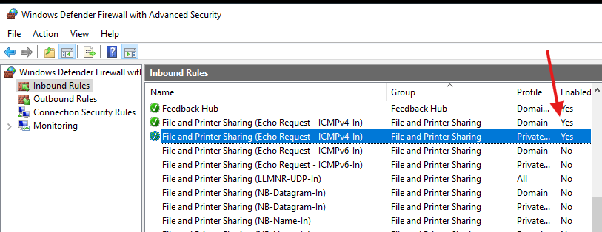

View this in status-firewall-at the bottom logs are seen

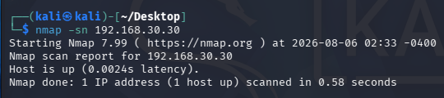

Phase 2 – Enable SMB (File Sharing)
Objective
Configure Windows 10 so Kali can perform:
- SMB Enumeration
- Share Enumeration
- SMB Version Detection
This is one of the most common enterprise reconnaissance techniques.

Step 1 – Set Network Profile to Private
Press:
Win + I
Go to:
Network & Internet
↓
Ethernet (or Wi-Fi)
↓
Your Network
Select:
Private Network
SMB discovery works best on a Private network.

Step 2 – Enable Network Discovery
Go to:
Control Panel
↓
Network and Sharing Center
↓
Change advanced sharing settings
Under Private, enable:
✅ Turn on network discovery
✅ Turn on automatic setup of network-connected devices

Step 3 – Enable File and Printer Sharing
In the same window, enable:
Turn on file and printer sharing
Click:
Save changes

Step 4 – Create a Shared Folder
Create a folder:
C:\PublicShare
Put a few files inside:
employee_list.xlsx
notes.txt
Project.docx
These are just dummy files for demonstration.

Step 5 – Share the Folder
Right-click:
PublicShare
Choose:
Properties
↓
Sharing
↓
Advanced Sharing
Check:
Share this folder
Share name:
PublicShare
Click:
Permissions
For now, allow:
Everyone

Read ✔
Do not allow Full Control.
Click:
OK

Step 6 – NTFS Permissions
Go to:
Security
Ensure:
Users

Read & Execute ✔
Read ✔
No need for Write permissions.

Step 7 – Verify Firewall
Open:
wf.msc
Ensure these rules are enabled:
- File and Printer Sharing (SMB-In)
- File and Printer Sharing (NB-Session-In)
If disabled:
Right-click → Enable Rule

Step 8 – Find the Share
Open Command Prompt:
net share
You should see:
PublicShare

Step 9 – Test from Kali
Discover SMB
nmap -p445 192.168.30.30
Expected:
445/tcp open microsoft-ds

Enumerate Shares
smbclient -L //192.168.30.30 -N
or
smbclient -L //192.168.30.30 -U labuser
You should see:
PublicShare

Connect to the Share
smbclient //192.168.30.30/PublicShare -N
or
smbclient //192.168.30.30/PublicShare -U labuser
Then run:
ls
You should see the dummy files.

Step 10 – Blue Team Validation
Verify that:
- Windows 10 Wazuh Agent is connected.
- Sysmon is running.
- Windows Security logs are being collected.
These will help detect SMB-related activity.

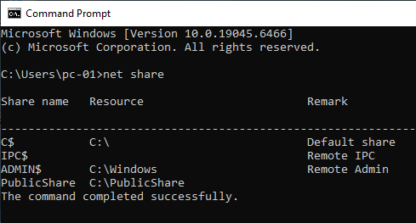

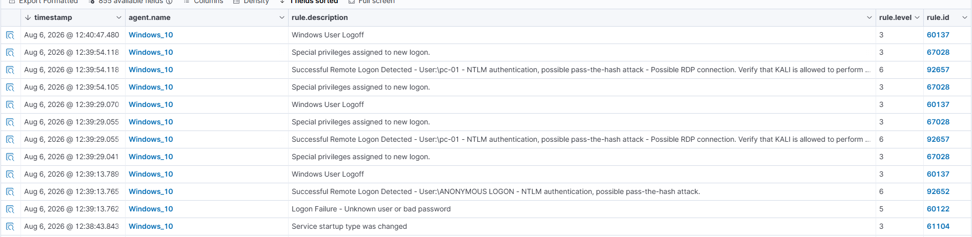
Logs generated for smb

Do this if error occurs
Step 1 (Most Important)
On Windows 10, open PowerShell as Administrator and run:
Get-NetFirewallRule -DisplayGroup "File and Printer Sharing" | Where-Object {$_.Enabled -eq "True"} | Format-Table DisplayName, Enabled
Take a screenshot or paste the output.

Step 2
Open Command Prompt and run:
netstat -ano | find ":445"
You should see:
TCP 0.0.0.0:445 LISTENING
If you don't, SMB isn't running.

Step 3
Open Services:
- Press Win + R
- Type:
services.msc
Find:
Server
It should be:
- Status: Running
- Startup Type: Automatic
If it is stopped:
- Right-click → Start

Step 4
Since this is a lab, let's quickly confirm whether Windows Firewall is the blocker.
Temporarily turn Windows Defender Firewall off for the Private profile only.
Then, from Kali:
nmap -Pn -p445 192.168.30.30
Results
- If it changes to:
445/tcp open
then Windows Firewall is blocking SMB, and we'll configure the correct inbound rules instead of leaving the firewall off.
- If it still shows:
445/tcp filtered
then we'll inspect pfSense.

Don't proceed to the next phase yet.
First tell me:
- Output of:
netstat -ano | find ":445"

then do this
smbclient //192.168.30.30/PublicShare -U pc-01
At the smb: \> prompt, run:
ls
You should see the files you placed in C:\PublicShare.
You can also try:
pwd
help
Exit with:
Exit
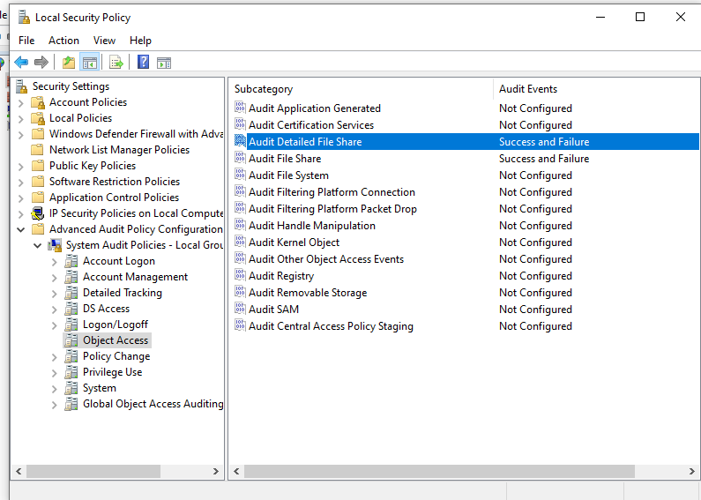
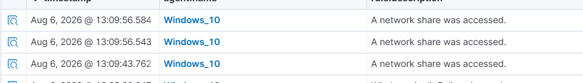
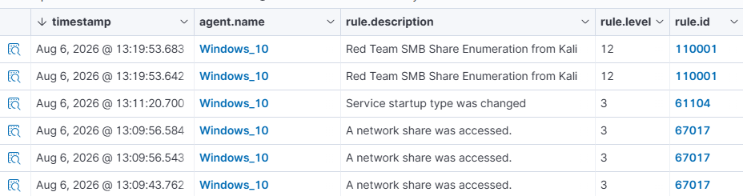
Wazuh logs shows smb was accessed from kali

